THE MESSENGER JULY/AUGUST 2021
GILEAD LUTHERAN CHURCH
PO BOX 26 CROPSEYVILLE, NY 12052
CHURCH PHONE: 279-9270
gileadlutheran.org gilead2@verizon.net
Service time 9:30 AM

A WORD FROM PASTOR JEFF SILVERNAIL

Summer 2021 Messenger – Pastor Jeff

“God saw everything that he had
made, and indeed, it was very
good.” Genesis 1:31a

For those of us who live in the great Northeast we realize that we aren’t known for our great weather. Winters are too long and summers too short especially when you factor in the summer days that are wash outs.

But it is summer – Halleluiah! – and it is time for us to slow down, enjoy the beauty of God’s creation, engage in some recreation and maybe – just maybe even relax.

As your pastor I want to encourage you to take that time. God made this creation to be enjoyed and appreciated – in fact God is the inventor of both pleasure and down time.

Let’s enjoy that gift and in enjoying it consider the God who made everything so good and gave us a special place in that creation.

“When I look at your heavens, the work of your fingers, the moon and the stars that you have established; what are human beings that you are mindful of them, mortals that you care for them?” Psalm 8:3-4

Wishing you all a safe and blessed summer,
Pastor Jeff

GILEAD’S VISION STATEMENT

We ring out a joyous message of welcome and togetherness to neighbors near and far through the Spirit of Christ!

VALUES FOR GILEAD LUTHERAN CHURCH
PRAISING GOD through Traditional and Contemporary music and Lutheran liturgy.
GROWING IN FAITH through Fellowship, Study, Prayer and Service.
STAYING CONNECTED with each other and reaching out to others in the community.
LISTENING for the Spirit’s guidance in all we do.
AFFIRMING each person as worthy of love and respect.

Please keep our homebound and those that can’t be with us in your prayers:
Bill Beck, John Grassman, Mike Boomhower, Matthew Raymond, Tom Spade, Kelly Nutter, Bob Guerin, June Boomhower, Rick Brown, Peter Valdeon, Liam, Joe Carista, Allen Sheffer, Audrey Hayner and Gretchen Ryan.

SUMMER SERVICE TIME 9:30AM

JULY BIRTHDAYS AUGUST BIRTHDAYS

Kathleen Sheffer 2 Stephanie Semon 2
Tanis Kreiger 7 Savannah Keefer 31
Victoria Jones 7 William Brown 23
Matthew Kreiger 8 August Keefer 23
Colin Erikson 12 Marion Brown 26
Emma Rose Faluszczak 13 Ricky Faluszczak 26
Noah Blair 26
Michael Shanahan 28

JULY ANNIVERSARIES AUGUST ANNIVERSARIES

Michael and Susan Kardash 5 Brian and Andrea Keefer 8
Nick and Stephanie Semon 9 John and Darlene Shanahan 12 Ronald and Kim Bugbee 22
Allen and Kathleen Sheffer 26

JULY CHURCH CALENDAR

6th Sunday after Pentecost, July 4th 8th Sunday after Pentecost, July 18th
Holy Communion Holy Communion
1st Reading: Ezekiel 2:1-5 1st Reading: Jeremiah 23:1-6
Psalm: 123 Psalm: 23
2nd Reading: 2 Corinthians 12:2-10 2nd Reading: Ephesians 2:11-22
Gospel: Mark 6:1-13 Gospel: Mark 6:30-34, 53-56

7th Sunday after Pentecost, July 11th 9th Sunday after Pentecost, July 25th
Holy Communion Holy Communion
1st Reading: Amos 7:7-15 1st Reading: 2 Kings 4:42-44
Psalm: 85: 8-13 Psalm: 145:10-18
2nd Reading: Ephesians 1:3-14 2nd Reading: Ephesians 3:14-21
Gospel: Mark 6:14-29 Gospel: John 6:1-21

AUGUST CHURCH CALENDAR

10th Sunday after Pentecost, Aug 1st 12th Sunday after Pentecost, Aug 15th
Holy Communion Holy Communion
1st Reading: Exodus 16:2-4, 9-15 1st Reading: Proverbs 9:1-6
Psalm: 78:23-29 Psalm: 34:9-14
2nd Reading: Ephesians 4:1-16 2nd Reading: Ephesians 5:15-20
Gospel: John 6:24-35 Gospel: John 6:51-58

11th Sunday after Pentecost, Aug 8th 13th Sunday after Pentecost, Aug 22nd
Holy Communion Holy Communion
1st Reading: 1 Kings 19:4-8 1st Reading: Joshua 24:1-2a, 14-18
Psalm: 34:1-8 Psalm: 34:15-22
2nd Reading: Ephesians 4:25 – 5:2 2nd Reading: Ephesians 6:10-20
Gospel: John 6:35, 41-51 Gospel: John 6:56-69

14th Sunday after Pentecost, Aug 29th
Holy Communion
1st Reading: Deuteronomy 4:1-2, 6-9
Psalm: 15
2nd Reading: James 1:17-27
Gospel: Mark 7:1-8, 14-15, 21-23

EVENTS CALENDAR

July 4th Quincy Galvin Baptism
July 13th and August 10th Council Meeting 6:30pm
July 29th and August 26th Body and Soul Pantry 3-5pm
September 11th Annual Chicken BBQ 4-6pm

WORSHIP LEADERS READERS

July 4 Pastor Jeff Silvernail Michele Krill
July 11 Deacon Jim Netzer Andrea Keefer
July 18 Pastor Dan Hahn Eleanor Bode
July 25 Deacon Jim Netzer Glenn Hayner

August 1 Pastor Dan Hahn Michele Krill
August 8 Deacon Jim Netzer Eleanor Bode
August 15 Pastor Dan Hahn Betty Britt
August 22 Deacon Jim Netzer Glenn Hayner
August 29 Pastor Dan Hahn Eleanor Bode

DIRECTORY UPDATE

DEADLINE SEPTEMBER 3RD We are working on updating our church directory. Please send us your current contact information if you would like to be included in the directory. If you know someone that would like their information in the directory please pass this message along. We would like to include name, address, phone number and email address. You can leave a message at the church 518-279-9270, email akeefer.gilead@gmail.com or mail us your information to PO BOX 26 Cropseyville, NY 12052

COMMUNITY MINISTRY

Our food Pantry is in need of the following items:
Toothpaste, Liquid soap, deodorant (mens and womens), dish detergent, macaroni and cheese, canned tomatoes, tomato sauce, canned corn, canned peas, canned carrots, canned potatoes, black beans and tomato soup. Thank you for your continued support.

FLIP COONRADT

The congregation of Gilead Lutheran is invited to a Celebration of Life for Flip Coonradt on what would have been her 90th birthday.

Saturday August 14th, Grafton VFW
Brief service at 12 noon, followed by food and fellowship.

BOTTLES

There has been a change in the deposit bottle disposal. The money collected from the bottles provided Thanksgiving baskets for residents of the Lansingburgh School system. The Shanahans will now redeem the bottles and the money will be used to provide Thanksgiving Baskets for the patrons of our food pantry.

We ask those who have faithfully turned their bottles to Gilead to please continue to do so. If you have not donated your bottles in the past, please consider joining our return policy so we may continue helping those in need.

GILEAD’S JOURNEY TOGETHER MAKES IT’S RETURN

Gilead Lutheran Church’s Journey Together returns after a lengthy pause for the pandemic. Saturday, June 12th, the group held a picnic on the church grounds for our first get together in over a year!

Each family brought a dish to share and an item Gilead’s Body & Soul
Pantry. The final request was to bring your favorite game and your comfortable lawn chair. Ants were not invited although Aunts were, and they brought Uncles with them.

There was quite a variety of food including appetizers, pasta salads, chicken, German potato salad and desserts. After our meal we relaxed and enjoyed the wonderful fellowship, the Baltimore Orioles nesting in our trees and the visitors from north of the border, the Canada Geese.

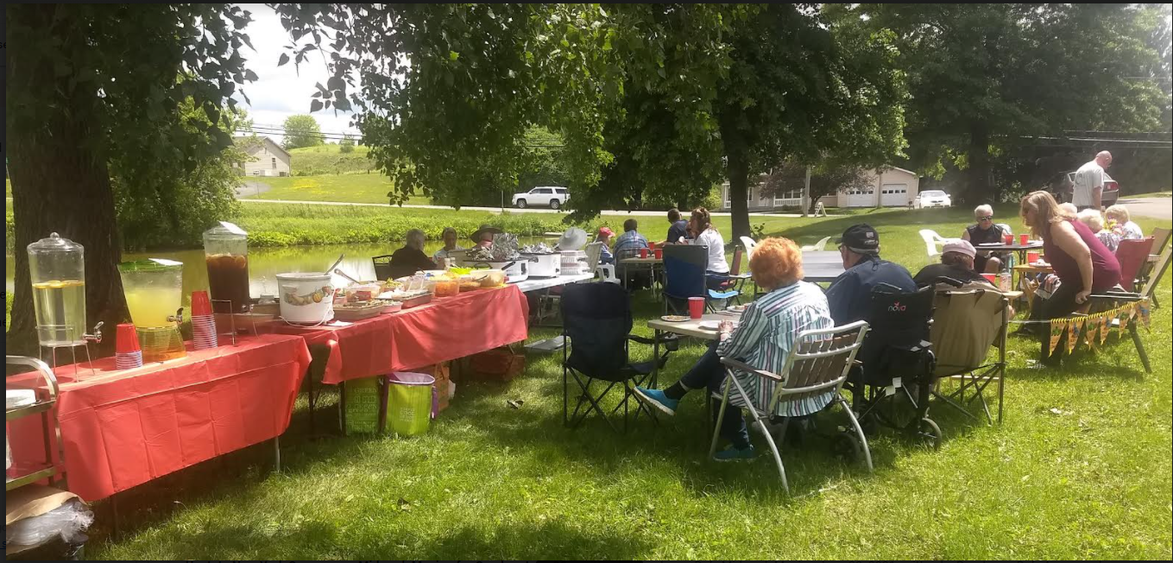

HELP WANTED

Andrea and Michele are looking for someone to help with the broadcasting of our morning worship services. It will take about an hour each week to setup and do the service. The video takes little or no time at all because the computer or phone will do all the work. Please contact Andrea, 518-598-2231, if you are able to help.

CHICKEN BBQ

Our annual chicken BBQ will be held on Saturday, September 11th. We will serve from 4-6pm. Dinners will be take out only. Reservations are preferred. Dinner will consist of half a chicken, baked potato, corn on the cob, coleslaw, roll and dessert. Dessert will be brownies and cookies. Cost is $12. Please call Jen Blair, 518-248-1295 for reservations.

GILEAD LUTHERAN CHURCH
PO BOX 26
CROPSEYVILLE, NY 12052

READ ME, SEE WHAT’S NEW!!

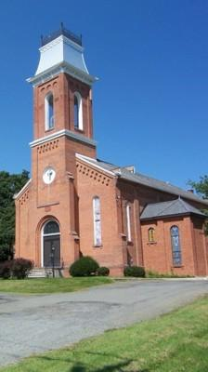

Gilead Lutheran Church
Brunswick, New York
Founded 1742

