THE MESSENGER JANUARY 2023
GILEAD LUTHERAN CHURCH
PO BOX 26 CROPSEYVILLE, NY 12052
CHURCH PHONE: 279-9270
gileadlutheran.org gilead2@verizon.net
Service time 10:30 AM

A WORD FROM PASTOR JEFF SILVERNAIL

January 2023 Messenger – Pastor Jeff

“Mary pondered what sort of greeting this might be.” Luke 1:29
“Mary treasured these words and pondered them in her heart.” Luke 2:19
“His mother treasured all these things in her heart.” Luke 2:51

Perhaps when you think of Mary you remember her as the one who had the faith to say “Yes” to God’s plan in spite of the personal cost she faced. Faithful Mary and Courageous Mary.

Maybe you think of her proclaiming God’s lifting up of the lowly and casting down of the mighty, in her Magnificat as she praised God to her cousin Elizabeth. Prophetic Mary.

Or you picture her pregnant and near term making the journey with Joseph to Bethlehem and then giving birth in a stable. Adventurous Mary and Resilient Mary.

Or you picture her at the cross or even as Michelangelo portrayed her in The Pieta. Grieving Mary, Suffering Mary.

With all of the pondering that occurs in the first chapters of Luke I’m beginning to think that Mary is the patron saint of introverts. She ponders things and treasures them in her heart. Reflective Mary, Contemplative Mary.

Sometimes I think we Lutherans and other Protestants don’t give Mary her due. What an amazing example of faith and what depth of character she exhibits. However you picture Mary I encourage you to ponder that image and treasure it in your heart.

Wishing you all a happy and blessed New Year!

Pastor Jeff

GILEAD’S VISION STATEMENT

We ring out a joyous message of welcome and togetherness to neighbors near and far through the Spirit of Christ!

VALUES FOR GILEAD LUTHERAN CHURCH
PRAISING GOD through Traditional and Contemporary music and Lutheran liturgy.
GROWING IN FAITH through Fellowship, Study, Prayer and Service.
STAYING CONNECTED with each other and reaching out to others in the community.
LISTENING for the Spirit’s guidance in all we do.
AFFIRMING each person as worthy of love and respect.

ANNUAL MEETING JANUARY 23RD AFTER SERVICE

Please keep our homebound and those that can’t be with us in your prayers:
John Grassman, Mike Boomhower, Matthew Raymond, Tom Spade, Bob Guerin,
June Boomhower, Rick Brown, Elaine Frank, Marcy Mulner, Greg Baxter, Joe Carista, Sharon Sigot, Joyce and Nicholas Banks, David Sweet, Kyle Kraft and Matthew Sheldon

JANUARY BIRTHDAYS

Kyla Blair 3 Gregory Jones 20
Barbara McGuinness 5 Marlene Shilling 21
Dona Kreiger 8 Meara Blair 21
Christopher Newton 17 Shi’Ann Faluszczak 22

JANUARY ANNIVERSARIES

John and Colleen Cameron 26

JANUARY CHURCH CALENDAR

Name of Jesus Jan 1st 2nd Sunday after Epiphany, Jan 15th
Holy Communion Holy Communion
1st Reading: Jeremiah 31:7-14 1st Reading: Isaiah 49:1-7
Psalm: 147: 12-20 Psalm: 40:1-11
2nd Reading: Ephesians 1:3-14 2nd Reading: 1 Corinthians 1:1-09
Gospel: John 1: [1-9] 10-18 Gospel: John 1:29-42

Baptism of Our Lord, Jan 8th 3rd Sunday after Epiphany, Jan 22nd
Holy Communion Holy Communion
1st Reading: Isaiah 42:1-9 1st Reading: Isaish 9:1-4
Psalm: 29 Psalm: 27-1
2nd Reading: Acts 10:34-43 2nd Reading: 1 Corinthians 1:10-18
Gospel: Matthew 3:13-17 Gospel: Matthew 4:12-23

4th Sunday after Epiphany, Jan 29th
Holy Communion
1st Reading: Micah 6:1-08
Psalm 15
2nd Reading: 1 Corinthians 1:18-31
Gospel: Matthew 5:1-12

WORSHIP LEADERS READERS

January 1st Pastor Dan Hahn January 1st Pastor Dan Hahn
January 8th Pastor Jeff Silvernail January 8th Leonard Flath
January 15th Pastor Jeff Silvernail January 15th Leonard Flath
January 22nd Pastor Jeff Silvernail January 22nd Eleanor Bode
January 29th Pastor Jeff Silvernail January 29th Eleanor Bode

EVENTS CALENDAR
January 3rd Worship and Music Meeting 5:30pm
January 10th Council Meeting 5:30pm
January 26th Pantry and Dinner 3-6pm

2023 Committee Chair

Caring Connections
Eleanor Bode

Community Ministry
Lisa Kreiger

Finance Committee
Robin Jones

Multi Community
Was Kat Raymond, Now ?

Parish ED
Jen Blair
Tori Galvin

Property
Glenn Hayner

Worship &amp; Music Committee
Dona Kreiger

If You Have Questions,
Please Address Committee Chair

Member News

News from John and Colleen Cameron about two of Gilead's confirmands, their sons, Johnny and Aiden:

"Johnny now works for Price Chopper on Sundays. He is also in soccer and doing well in school. Aiden was in San Antonio, Texas in the Air Force basic military training for three weeks where he graduated on November 10th. Luckily, we were able to get tickets to fly down on the 8th to see him for a couple of hours before they shipped him off to Gulfport, Mississippi. There he will learn to be a structural engineer at the Naval Construction Training Center for about six months. After that he will be promoted directly to E-3, Airman 1st Class; currently he is E-1 Airman Basic. The school starts on the 25th of November and after the second week he should find out what his first duty station will be. It’s all exciting!! We are currently trying to make sure he has all he needs. It is pretty exciting. He has a lot going for him and his future looks bright. Tell everyone I said hello!

John Cameron III
Semper Fi"
Kids Christmas Party

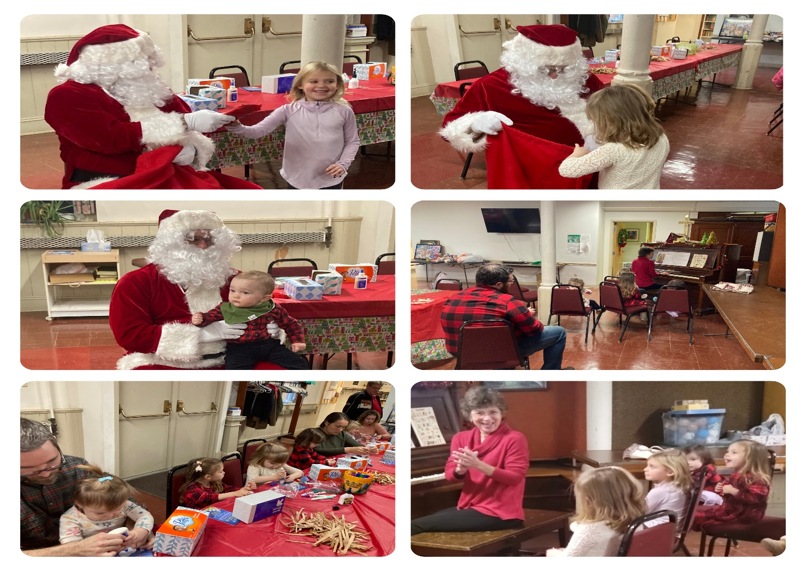

Sunday School News
Thank you to everyone who helped out and/or attended the Gilead Sunday School Christmas Party! During the service, we handed out some Christmas Snack Mix as a gift from the Sunday School to remind us all of the reason for the season. After lunch, we made our own Nativity scenes to bring home, sang our favorite Christmas carols, and even had a very special visit from Santa! We also read a special story called Mortimer’s Christmas Manger by Karma Wilson that is a very sweet retelling of the Advent story, through the eyes and ears of a mouse.
Our regular mailings will return for the month of January. This month, our children and their families will be learning about how Jesus made his disciples Fishers of Men. If you know someone who would like to be included in our mailing list, please let Tori know.

Christmas Eve Service
On Christmas Eve Gilead hosted a 2nd Annual Carol Singing Bonfire. This was a fun way to celebrate the birth of Our Lord with the community, thank you to all who attended despite the weather.
Following with was a beautiful Christmas Service by Pastor Jeff Silvernail.
Thanks to Dona Kreiger for some amazing photos.
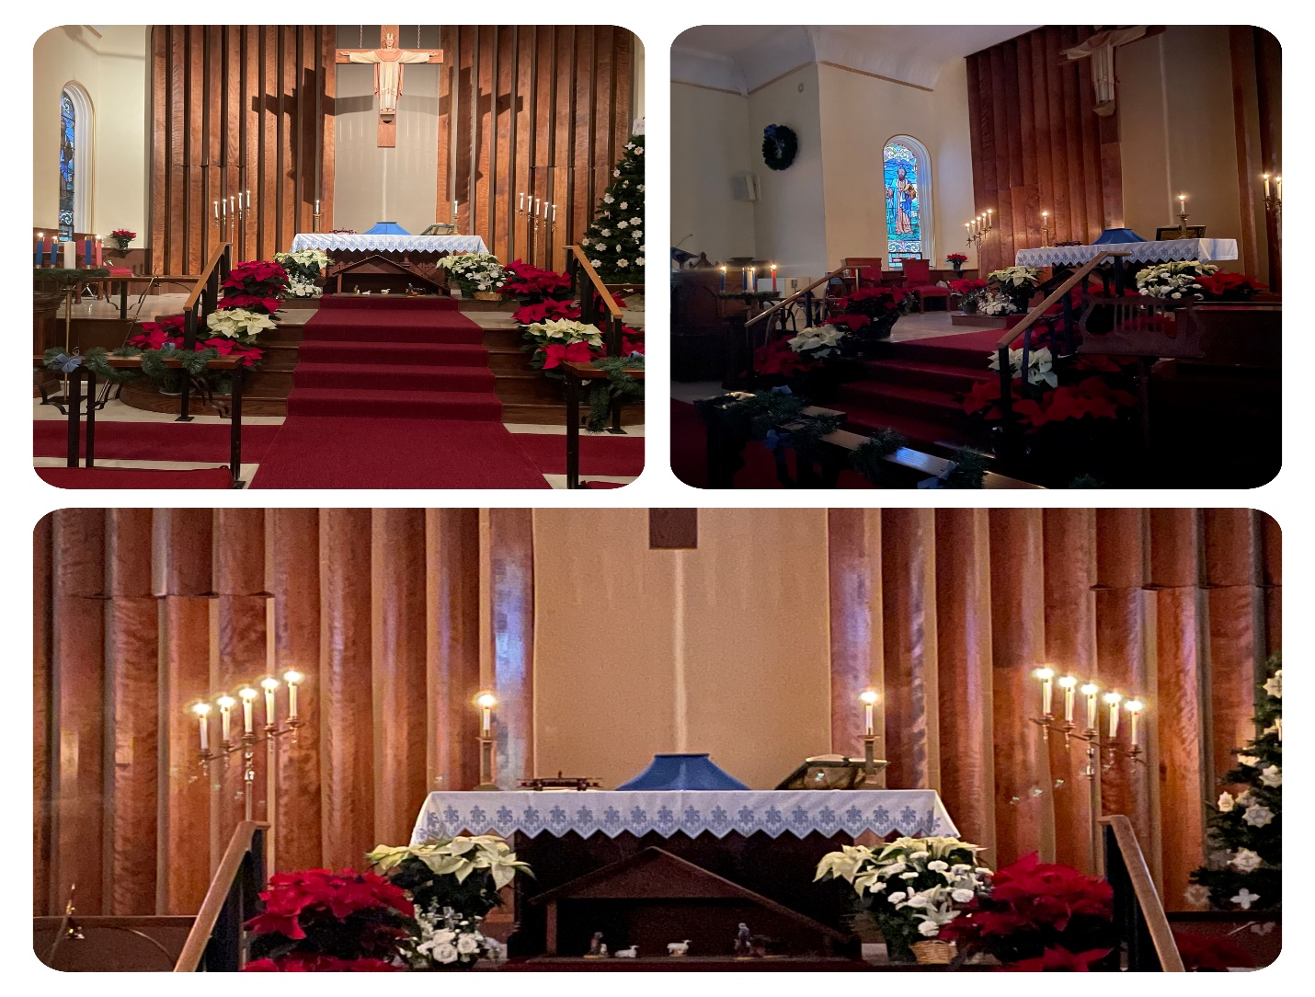

Community Ministry

Community Ministry would like to thank all who helped shop and people who donated money to help buy presents for our pantry families. We were able to provide 4 families and a total of 13 children presents this year. Without the support of the whole congregation, we would not be able to do this outreach. I would also like to thank the Brunswick Grange for their donations to our pantry. Happy New Year! Lisa
BIBLE STUDY

Will resume on January 11th. We will be studying the Sermons on the Mount and the Plain.
Pastor Jeff

"THANK YOU NOTE"
Thanks to John and Darlene Shanahan for organizing and delivering the cookies and all the cookie makers for making it possible to send "Christmas cookie greetings" to the NYS Police, Mohawk Ambulance, and the Town of Brunswick.

Thanks to Bill and Donna Charette and Charles Keefer for organizing the bon fire and carol sing on Christmas Eve. Bringing in a water supply and wooden pallets was a bit of work. Attendance was low assuming it was because of the cold night - but the fire was keeping the few warm. Thanks for joining us Pastor Silvernail.

Thanks to Lisa Kreiger for organizing the outreach to some children who needed some extra gifts on Christmas and thanks to those who picked a name to shop for. There were surely some happy faces of the children who received the gifts.

And thanks to all those who showed up at church to decorate for Christmas. Gilead was looking its very best with blue bows and then the change to red. A stunning sight!

There are so many ways to serve Gilead - we welcome your participation!

Eleanor Bode

ANNUAL MEETING JANUARY 23RD AFTER SERVICE
THANK YO

***Annual Reports are due ASAP***

December messenger word puzzle answers.
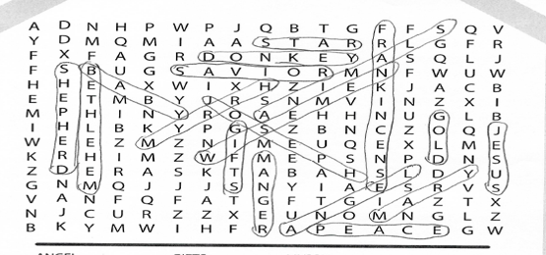

Cube Steaks with Gravy

Ingredients
- 1/3 cup all-purpose flour
- 6 beef cube steaks (4 ounces each)
- 1 tablespoon canola oil
- 1 large onion, sliced and separated into rings
- 3 cups water, divided
- 1 envelope brown gravy mix
- 1 envelope mushroom gravy mix
- 1 envelope onion gravy mix
- Hot mashed potatoes or cooked noodles

Directions
- Place flour in shallow dish. Add steaks, 1 or 2 at a time, and turn to coat completely.
- In a skillet, cook steaks in oil until lightly browned on each side. Transfer to a 3-qt. slow cooker. Add the onion and 2 cups water. Cover and cook on low for 8 hours or until meat is tender.
- In a bowl, whisk together gravy mixes with remaining water. Add to slow cooker; cook 30 minutes longer. Serve over mashed potatoes or noodles.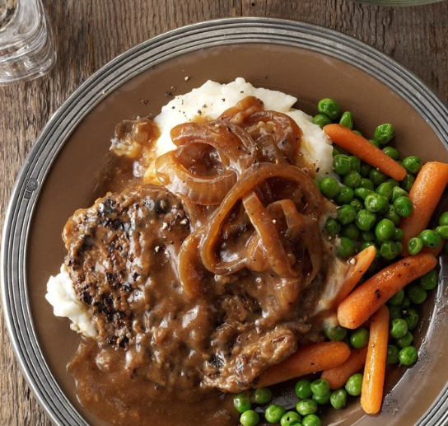

GILEAD LUTHERAN CHURCH
PO BOX 26
CROPSEYVILLE, NY 12052

READ ME, SEE WHAT’S NEW!!

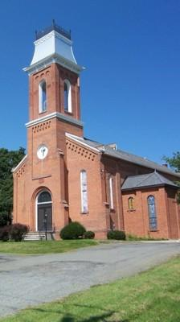

Gilead Lutheran Church
Brunswick, New York
Founded 1742

